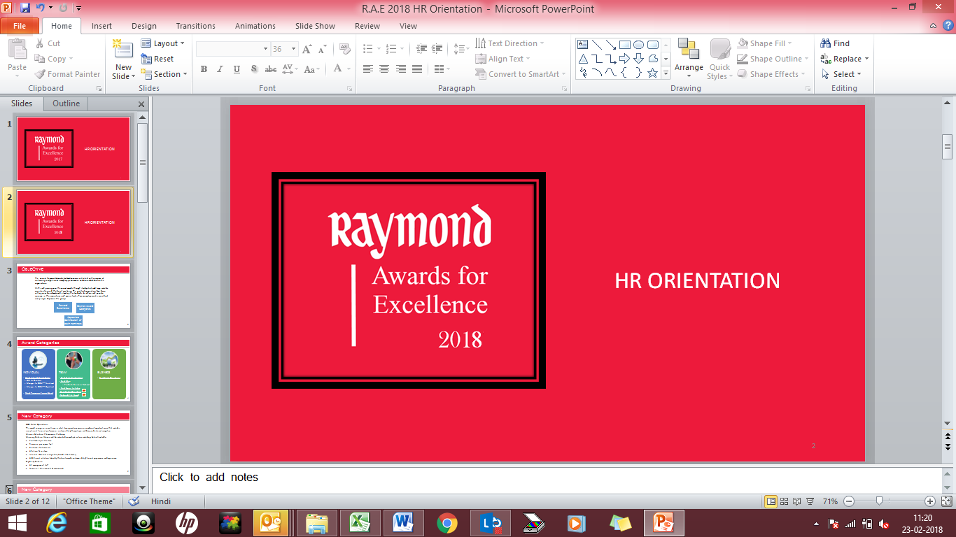

Most Promising Young Talent

Nomination Form

Guidelines:

- Please complete this form and submit with any relevant supporting documents to your respective SBU Head (President level) along with a copy to awards@raymond.in
- Please attach ONE high resolution photograph of the nominee along with the nomination form.
- Submit any documents/pictures that you think would build a strong case for this nomination.
- The Awards Committee may contact you to collect additional details, if necessary.
- Mention the subject line as ‘Most Promising Young Talent’ when submitting your nomination

Eligibility Criteria
  - Grade – Assistant Manager, Deputy Manager, Executive and Management Trainees
  - Age group of less than 30 years as on 31st January 2018
  - Minimum tenure of 1 year with Raymond as on 31st January 2018
  - Maximum number of Winners - 13 [Lifestyle = 7, Engineering =2, Corporate =1, Denim =1, JK Ansell =1 JK HC =1], refer annexure for more details.

Winning Criteria: Winners will be assessed on multiple criteria including, but not limited to:
  - Exemplary contribution in the current role
  - Active participation in strategic initiatives, CFTs
  - Demonstrated initiative, performance orientation, creativity, commitment & sense of ownership
  - Behavior exemplifying Raymond Way of Leading /Culture Pillars

NOMINATOR DETAILS
Name
Business |  |  | Location
Phone |  |  | Designation
NOMINEE DETAILS
Name |  |  | Photograph
Department / Business
Location
Designation / Role
NOMINATION
Overall Performance: Describe the overall performance of the nominee during the year
The Achievement: Describe the specific contribution for which the nominee is being nominated in quantifiable terms. Detail the ‘What’ & ‘How’ of the achievement and the ‘Impact’ of the same in quantitative and qualitative terms.
The Innovative Solution: Did the above achievement contribute towards solving an existing issue in the team / department / organization innovatively? How?
Alignment to Competency Framework : Instances which highlight nominee behavior is in alignment with Raymond way of Leading
SBU Head’s Recommendation / Remarks: Substantiate your reason for recommending this individual
As far as possible, provide robust quantifiable parameters that measure impact or ROI. This will clearly help identify outstanding ideas or innovation. Some illustrations on measureable parameters could be:

- Percentage increase in the top/ bottom line
- Reduction in the total cycle time/ lead time
- Cost containment, savings or reduction
- Reduction in percentage errors
- Revenue generation
- Customer feedback
Thank You.

